“Amazing Opportunity for Your Wrestler”

Greco-Roman Wrestling Camp’s

Taught by
Justin Ruiz, 7 x U.S. Nationals Champion (Greco-Roman) and
Asst. Coach at UVU

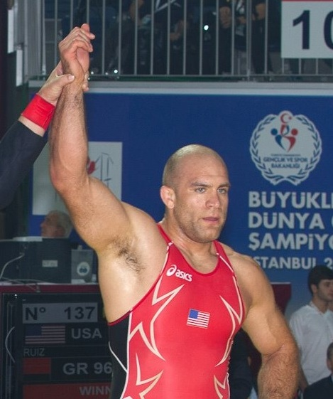

1st Camp: K-6th Grades Cost: $100
February 18 – February 20, 2013
6:00 – 8:00pm
Orem High School
Registration will be at the door from 5:30pm to 6:00pm

2nd Camp: 7th – 12th Grades Cost: $100
February 25 – February 27, 2013
6:00 – 8:00pm
Orem High School
Registration will be at the door from 5:30pm to 6:00pm

Greco-Roman wrestling technique will be taught at both of these camps and will provide instruction to youth who will be competing in Greco-Roman events throughout the spring and summer or for those wrestlers who just want to add an extra arsenal to their technique. This camp will make the participants feel more comfortable with the Greco-Roman wrestling style and increase participation in Greco-Roman wrestling events. If you have any questions, please email Justin at justinruizwrestling@gmail.com or message him via Facebook.

Justin Ruiz knows Wrestling!!

